Join The Hollis Art Society for a Pastel Workshop
What is pastel artwork? What types are there? Why is one better than another?
In this workshop you will learn about strokes, blending, basic layout, surfaces, fixative, framing, storing unframed, and transporting your work.
The fished project will be a landscape replicated from the photos you bring.
Date: September 24, 2022
Location: The Lawrence Barn, 28 Depot Rd, Hollis NH
Time: 10-4
Cost: $80 Members
$100 Non-Members
How to register: Mail in a registration form with a check. Please make check payable to Hollis Arts Society NH. Please mail check to Grace McGinnis, Hollis Arts Society, Box 102, Hollis NH 03049
To pay by credit card contact Wendy Walter. wwaltervoiceofclay@gmail.com 603-400-5171

What you Need:
- 8-10 pure pigment pastels (not oil pastels). Beginners work best with medium density such as Nu-Pastel. If you are experienced with pastel, medium and soft density is fine (bring what you have).
- One or two pastel pencils
- One or two small charcoal sticks
- Pastel paper. Canson is widely available or sanded paper (more expensive). You don’t need both
- A pastel eraser
- A firm smooth-surfaced board to attach the paper to. Foam board is lightweight and works well
- An easel if available
- Three landscape photos without architecture and a variety of complexity

Where to Purchase Supplies:
- Dickblick.com 617-441-6360
- Jerrysartararama.com
- Michaels Stores
- Amazon.com/artist-supplies (Amazon carries a Royal Langnickel set that has most of what is needed reasonably priced.
- Questions about materials needed? Contact Grace: ghsmcg@gmail.com

The Instructors

Grace McGinnis

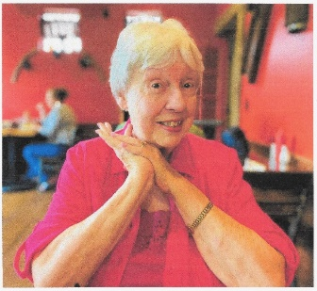
Grace grew up in the Mount Hope Bay region of southern MA, on a dairy farm. During high school, she was fortunate to be selected to attend a Saturday semester-long program at the Museum of Fine Arts in Boston. Grace received a B.S. from Drexel University in clothing design and pattern. She was employed in the industry until the birth of three children and then volunteering kept her busy. Later Grace was employed in social services until retirement. About the year 2000, art called again. She studied with various local artists and has shown her work in NH. MA. and R.I. She taught at the Rise Program at Rivier University and teaches private lessons to individuals with cognitive disorders.

Laureen M. Luszcz

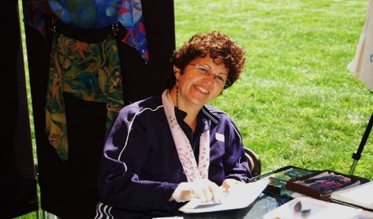

Since her first introduction to the pastel medium, Laureen has enthusiastically pursued her passion for creating colorful and peaceful landscapes. Although her favorite subjects are coastal and natural scenes, she has expanded her interests to include still life, buildings, abstracts, drawing from life and portraits.
She is taking a new look at her art and experimenting with blending many different mediums to create new exciting art. She starts with something familiar and then adds shadow, light, colors, etc. expressing her visions in her art.
Laureen has exhibited her artwork at the MCC Student Art and Design Juried Show, at the Lowell Telecommunications Corp.- (LTC); The Wakefield Fine Art Show, 100th Anniversary-Wakefield Civic Center, Wakefield Cooperative Bank, sponsored by the Wakefield Chamber of Commerce; First Congregational Church, sponsored by the Reading Art Association, the Nashua and Nevins Memorial Libraries, and the Hollis Art Society. Laureen has been awarded special recognition in several juried art show in New Hampshire and Massachusetts.

